EEA and Norway Grants: 2nd Network Meeting of the Health Programme: Prevention in the Field of Child and Adolescent Mental Health

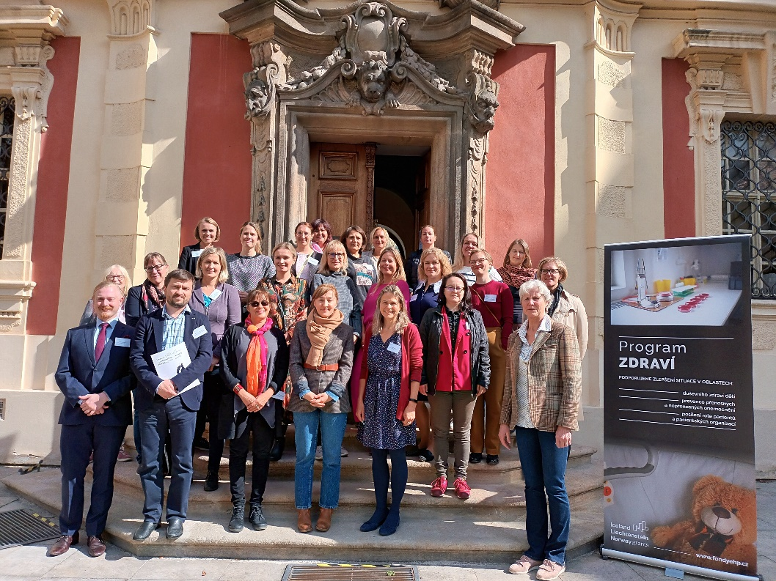

The 2nd Network Meeting of the Health Programme: Prevention in the Field of Child and Adolescent Mental Health, took place on 21-22 September 2022, at the Antonín Dvořák Museum in Prague, Czech Republic. The meeting brought together partners from Norway and Iceland (representing the EEA and Norway Grants), and grant recipients from the Czech Republic, Estonia, Lithuania, Poland, and Romania. The purpose was to advance the objectives of the network, as set out in the terms of reference agreed after the first meeting in 2019 (See Annex 1). These terms of reference include the exchange of experience, challenges and lessons learnt, strengthening partnerships, and contributing to sustainable and effective programme implementation. At the two-day meeting, country representatives first provided general overviews of the current situation in their country. They then presented specific mental health prevention programmes and services that they were implementing, including in-person (in kindergartens and schools) and online. The meeting also focused on refugee children and youth and the sustainability of the various initiatives. Partners also had the opportunity to take part in a site visit to a General University Hospital, where they visited an educational and therapeutic centre, and a paediatric department working with children born prematurely to protect and promote their mental health.
The exchanges over the two days reflected how mental health services in community and primary-care settings are: “underdeveloped, underfunded, underprioritized and under-resourced” in many European countries (Livia Cioran, Romania).
Problems like anxiety, depression, eating disorders and self-harm are very prevalent amongst children and youth in participating countries and, in some cases, are growing. However, many interventions are being implemented to address the situation. All participating countries are investing in more low-threshold, accessible, community-based initiatives that promote more positive conceptualisations of mental health, provide information, support and counselling, and encourage dialogue and connection. Such approaches can prevent mental health problems from emerging in the first place or from becoming more chronic. Well-designed digital tools are a key part of the solution. However, ensuring the sustainability and impact of such interventions requires well-aligned policies and strategies, and bottom-up as well as top-down action that prioritize preventative approaches to child and adolescent mental health.
DAY ONE
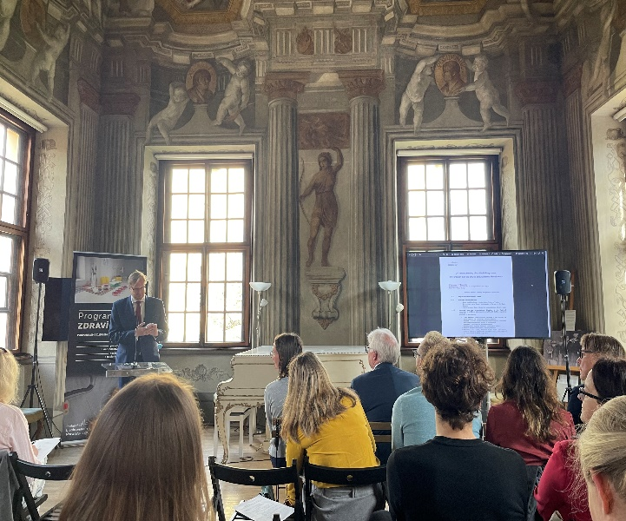
Welcome and introduction
Matouš Duraj, from the Czech Ministry of Health and the Deputy Minister at the Czech Ministry of Health Jakub Dvořáček opened the meeting by thanking the Ministry of Finance for hosting the event in such a beautiful venue (the Antonín Dvořák Museum). The Deputy Prime Minister also thanked the donors for establishing the EEA and Norway Grants, as a mechanism to build public society. He stressed that the focus of the meeting was very important to the Czech Presidency of the Council of the European Union. A Conference on mental health for example took place under the auspices of the Czech Presidency, which included a focus on refugee children from Ukraine, at a time when 400,000 Ukrainian children are currently being hosted across the EU.
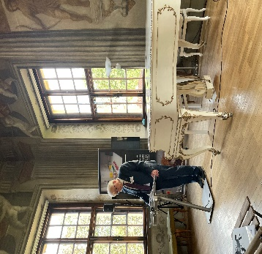
In his introductory comments, Per Øystein Vatne, Deputy Ambassador of Norway to the Czech Republic noted that the area of mental health has been a part of the of the EEA and Norway Grants since the very beginning. He thanked participants for their contributions to the de-stigmatization of mental health, and stressed that the most important issue is prevention.
Amongst her introductory comments, Solfrid Johansen, Senior Advisor at the Norwegian Institute of Public Health (NIPH) raised the pandemic and the unthinkable consequences of the war in Ukraine, which are having critical adverse impacts on mental health and forcing us to address new challenges that we took for granted pre-pandemic. Current events have made it increasingly clear that mental health is affected by factors beyond health. She noted that ever since the EEA and Norway Grants began their work in 2011, mental health has been a significant part of the programmes, which, in turn, have been influential in shaping mental health in the beneficiary countries. Despite the gloomy times, she hoped that the fruitful discussions would release lots of positive energy and useful reflections.
Countries’ overview presentations: Situation in the field of prevention of child and adolescent mental health in the respective countries
In the first session of the meeting, moderated by Matouš Duraj, a number of participants presented on the situation in the field of prevention of child and adolescent mental health in their countries:
Ivana Svobodová, Secretary of the Council for the Mental Health of the Government, Ministry of Health, Czech Republic began by saying that a focus on the issue of mental health in the Czech Republic only began two to three years ago, with developments like the ‘’Care for Yourself” website, Positive Parenting Programmes, and the Positive Behaviour Interventions and Supports (PBIS)-Trauma informed approach being piloted in schools. In addition, public messages on mental health will be further disseminated on the internet and Czech television, while new TV programmes will also include a focus on this topic.
These initiatives have only been introduced in some locations across the Czech Republic, but have proven very successful, so the Ministries of Health and of Education would like to implement them more widely. There are also information leaflets, posted on Facebook and targeted at both children and youth focusing on themes such as: how to talk about war, what to do about anxiety around returning to school, and how to help prevent mental health problems. As a result of the COVID-19 pandemic, Czech insurance companies are preparing to offer financial support for psychotherapy, and talks are underway to provide insurance coverage for parenting programmes. There are also more possibilities to hire psychologists and special educators in schools. At the same time, there are not enough psychologists for children, and more non-medical therapists are needed. There is also a lack of crises services, help-lines and other mental health-supporting social services in the Czech Republic.
Triinu Täht, Prevention and enhancement policy coordinator, Mental Health Department, Ministry of Social Affairs, Estonia presented on “new beginnings” and how the mental health system in Estonia is being revamped. She works at the new, specialized, Mental Health Department established within the Ministry of Social Affairs, which will be responsible for implementing a new Mental Health Framework and its accompanying Action Plan. Ms. Täht set out how until fairly recently, mental health was only considered relevant if something was really wrong -otherwise the attitude was: ‘’pull yourself together, man.” The Mental Health Plan of 2008 reflected a shift to the understanding that health is an investment, not an expense, but the primary focus was still on ‘building things’, like hospitals -not in investing in ‘’soft stuff’’ like people. Slowly, however, the focus shifted to a more systemic approach to the mental health of children and youth, that also considered underlying determinants. There was also a realization that there are lot of actors engaged in mental health and that a broader coalition was needed to coordinate efforts, leading to a network. As a result of the Covid-19 pandemic there is now a recognition that this is an issue that affects not just children and youth, but the wider population. Estonia therefore now wants to build a solid mental health pyramid, with services and initiatives that provide support to everyone at the base (like mental health literacy, self-help, and education). The aim is to also invest in support groups and councillors, so people don’t have to wait, and to incorporate these into general practitioner practices and primary care services. This will however take a lot of work. The aim is also to incorporate mental health in all policies, not just in health policy. Ms. Täht noted that the education sector is one of the toughest to get to, although there is growing awareness of the need. She noted that the emphasis must be on prevention, and on removing the reasons why people have mental health problems, in work places, schools, and other settings. She also stressed that the ‘do no harm’ principle is crucial; mental health is becoming very popular, and there are more and more charlatans entering the market.
Justina Račaitė, Ministry of Health, Lithuania set out the some of the challenges in relation to mental health of children and adolescents in her country, which include: insufficient support of parents and teachers, education systems that do not support mental health, violence in the family, high levels of bullying in school, early intercourse and pregnancies, use of psychoactive substances and suicidal behaviour. She noted that existing support services in Lithuania were more like a square than a pyramid, and that more emphasis was needed on strengthening community-based services. Programmes funded under the EEA and Norway Grants are helping to make this change, however, through initiatives such as the establishment of health offices in pre and primary schools with training and tools in relevant methodologies. Ms. Račaitė also noted that the home visitation early intervention model programme (nurse family partnership) that is being funded through the EEA and Norway Grants is has been very successful in Lithuania, and that they are working hard to continue to fund it through state insurance funds in order to have it throughout the country in the near future. Youth-friendly care service provision models, where youth with eating disorders or suicidal thoughts can come, are being adopted/extended and implemented throughout the country in accordance to the needs of municipalities. There were currently 24 health centres with youth coordinators providing such services. In addition, Lithuania is adapting and rolling out the Incredible Years Programmes through sustainable financing from the EEA and Norway Grants, the EU and the government, to make it available to all parents after 2023. There are also plans to incorporate a module for children in the autism spectrum and, in 2023-2024, to roll out the ‘’Nurturing care” programme on maternal and childhood health and well-being.
Astrid Nylenna, Directorate of Health, Norway presented on the Norwegian system for children and youth and the mental health situation during the pandemic. She noted that all services in Norway are free of charge, and that doctors, midwives and nurses were part of municipal health services which include mental health care and rehabilitation services for substance abuse. In addition, school health services are available to all children, who are taught about e.g., sexual health, tobacco and nutrition. Their aim is to ensure a good and safe school environment, through health promotion and prevention work based on the needs of children and youth in the school. School nurses are available for drop-in consultations. There are also youth health centres that provide information on sexual and reproductive health rights, detect mental health problems and disorders, and offer follow-up consultations and treatment. The services are adapted to the specific needs of the community.
An act has been in place in Norway since 2020, which states that all municipalities must provide counselling services, so that these services are closer to communities. A public agency provides advice and guidance to municipalities on the establishment of measures and initiatives for children with special needs. They also collaborate with municipalities on how they can provide outpatient mental health services for children, while the aim is to ensure all municipalities integrate psychologists in their health and care services (currently only a few do so).
Ms. Nylenna presented the results of a regular national youth survey, “Ungdata”, which demonstrated that most youth in Norway are well-adjusted, feel that ‘life is good’ and that they have what they need in life. The percentage of youth that indicate that they expect to lead a good life is decreasing, however, and levels of loneliness, stress and anxiety related to school are increasing. 27% (of 140,000 youth surveyed) responded the COVID-19 pandemic had affected them “quite a lot”. Primary care providers and other health services and specialists experienced a sharp increase in the number of inquiries related to mental health difficulties, and struggled to meet the rising demand. They reported a large increase in numbers of youth suffering from eating disorders over the past two years, as well as trends towards younger and sicker youth with eating disorders.
Ms. Nylenna also mentioned a “Failure and Betrayal” policy green paper which found that children in need in Norway often do not receive appropriate help, due to a lack of collaboration across sectors. Efforts are being made to address this. An new policy, the ”Escalation plan for good mental health among children and adolescents”, is being developed. It aims to promote mental health and reduce social differences amongst adults and young people, through e.g., nourishing family and parenting skill programmes, better learning environments, safe digital spaces, promoting youth involvement, and strengthening research and knowledge in these areas.
Marcelina Mroczkowska, Ministry of Health presented on the situation regarding the mental health of children and youth in Poland, where it has been estimated that mental disorders affect approximately 10% of the population of children and adolescents. This indicates that over 600,000 people under the age of 18 in Poland require mental health support. Mental health problems are manifesting in the form of low self-esteem, lack of assertiveness, lack of critical thinking, lack of ability to live in society, suicidal tendencies, depression and self-harm. There has also been an increase in aggressive and self-destructive behaviours. This reflects a grave need for prevention and therapeutic support programmes, in the form of psychological support, individual counselling, support groups, and workshops on self-esteem. COVID-19 affected those in lower socio-economic groups, in particular, as a result of the closure of schools (off-and-on for a total of approximately 1.5 years in Poland). In addition, it is very difficult to access psychological care, as there is a lack of service providers (for example, there were only 482 child psychiatrists in the country as of Feb 28, 2021). There is also an inadequate number of school psychologists.
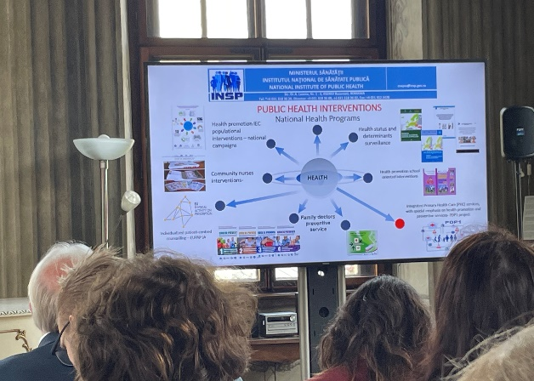
The first Mental Health Centre was established in Poland in 2018 as part of a pilot programme. It provides many forms of stationary (in-hospital) treatment, as well as daily treatments and individual and group therapy in the community. A new programme, the “Healthy Future, Strategic Framework for the development of the health care system, 2021-2027”, is being implemented. It will lead to the development for more in-patient and outpatient psychiatric and psychological services (diagnosis and therapy) for children and adolescents, free of charge. The aim is also to strengthen human resources through the development of new specializations, addressing different levels of need and urgency, so that only patients that need psychiatric diagnosis or pharmacological therapy are referred to a psychiatrist, and others receive other forms of help (psychotherapy or environmental therapy.)
Livia Cioran, National Institute of Public Health, Romania, noted that Romania has over 4 million 0-18 year olds, with 52.6% living in urban areas. There is a school based medical network, but only 8.6% of schools have a general medical office. Most rural areas do not benefit at all from such services. Mental Health Data and Information from the NIPH-Regional Centre of PH Sibiu reflect how rates of depression amongst children and youth increased from 14.3% in 2013 to 21.9% in 2021. The data also reflects that Romania is “facing a new situation” in this area, as children with parents who are working abroad are much more likely to have autism spectrum disorders, anxiety disorders and ADHD.
HBSC data reflects that the most risky behaviour that children and youth engage in (with possible impacts on their mental health) is alcohol consumption, with 13% of 15 year old boys and 8.6% of 15 year old girls reporting being drunk at least once in previous 30 days, and 19.91% of youth indicating that they started consuming alcohol at 13-14 years of age.
Further data presented reflected that levels of drug use, betting, gambling, and (cyber-)bullying are also high, particularly amongst boys, though trends show some declines. There are differences between rural and urban areas, due to different “traditions”, so the data may not reflect the full extent of such problems.
Ms. Cioran also briefly presented on the structure of public health in Romania, where responsibility is shared between the National Institute of Public Health and four specialised Centres. In addition, there are six Regional Centres and 42 Public Health Directorates responsible for implementation of public health services. A number of programmes are running at the national level which could contribute to improving child and adolescent mental health. These include community nursing interventions, integrated primary care services, and school health promotion programmes. There is also a programme that runs promotional campaigns for the population at the national level, including the ‘’Together for mental health”, and “No Health without Mental Health” campaigns that aimed to remove stigma around mental health. The National Centre for Mental Health and Anti-drug Action is largely responsible for the coordination, implementation and evaluation of national mental health policies, including the National Strategy for Child Mental Health.

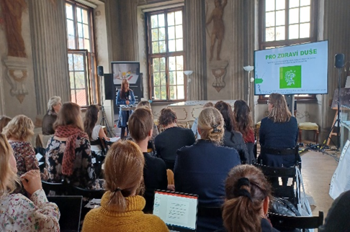
Promoting mental health in kindergartens/schools
The second session on “Promoting mental health in kindergarten/schools” was moderated by Livia Cioran.
Táňa Zimmermannová, from Palacký University Olomouc in the Czech Republic presented on the Pro Zdraví Duše project that aims to support educators by creating a support network in the area of ​mental health of children, pupils and students. The main idea and vision of the programme is that children misbehave because they don’t know better, and they may have been experiencing (or currently experience) trauma which fundamentally affects their development and engagement with society. The project wishes to address these challenges. Above all, it is crucial to “relate, relate, relate” to win a child’s trust and heart, so that things will go much more smoothly. The Programme is based on the Positive Behaviour Interventions and Supports (PBIS)-Trauma informed approach, to promote a good climate in schools. It essentially involves the establishment of mental health teams, comprised of a case manager, psychologists, teachers, and parents, who observe and discuss the behaviour of a child that is facing difficulties, and agree on and implement a plan of action. The aim is to help all those interacting with a child to do so in more constructive ways which promote their health and well-being. Sometimes, psychiatrists may be involved, to help with specific crisis situations. The programme implementers receive the support of their Norwegian counterparts.
Ms. Zimmermannová noted that Czech kids dislike going to school, and that their PISA outcomes are amongst the lowest in Europe. This can be changed through the introduction of more didactic tools that enable educators to approach children and youth in such new and effective ways that protect and promote their mental health.
Justina Račaitė, Ministry of Health in Lithuania, set out a number of measures that come together nicely to protect and promote the mental health of children and youth in schools in Lithuania. Public Health Bureaus, located throughout the country, include public health specialists that provide services in schools, including mental health services. These specialists have knowledge of the determinants of mental health and monitor what is happening in schools so they can intervene in a timely fashion when issues emerge, and not just in acute crisis situations. Their role goes well beyond acting as school nurses; they are public health leaders who can connect relevant actors to help address any underlying determinants of ill health. Big urban schools may have one specialist, while in rural areas a specialist may be responsible for different schools. Schools also employ psychologists, who develop and implement prevention programmes, and educate the school community. In addition, all schools in Lithuania have a Child Welfare Commission, whose mission is to ensure a safe and favourable educational environment for the child, and that also works with other actors to help ensure this. There are also Youth Health Care Centres where youth can come after school if they need support.
Dariusz Juszczyński, Ministry of Health, Poland, presented on the third module of the Healthy Lifestyle of Children and Youth Programme, being co-financed by the EEA and Norway Grants. It focuses on mental health, including elaborating information and training materials on methods to help children and youth with mental health problems. It will also provide trainings to parents, teachers and carers and set up a website with e-learning courses, training materials for teachers and carers and information materials for children and youth.
Working with Norwegian partners, the programme implementors first identified good practices to implement into Polish context, adapting where needed. The initiatives will start small, but the aim is to roll them out further in phases. In addition, an investigation (including an online survey) was undertaken in the Verdal municipality in Poland. The investigation explored what existing digital infrastructures, digital tools and prevention and promotion activities were already in place and being used. The questionnaire found that parents were most likely to seek out information, but to do so only when an acute problem had already presented itself. Parents turned primarily to the internet for help, and secondly to psychologists, doctors, or friends for information. Mr. Juszczyński noted that the internet and other parents might not always provide accurate or reliable information, confirming the need for a good on-line resource on how to diagnose and respond to common mental health issues like depression, eating disorders, and anxiety. The project implementers are now in the process of tendering to develop a website and for the materials to be disseminated amongst a wide range of target groups (young people themselves, school professionals, carers, etc.). They also plan to run workshops and develop training materials for teachers and parents in the near future. Following the presentation, the moderator indicated she would like to have a copy, since the programme is very similar to the one being implemented in Romania.
Diana Stanculeanu, National Centre for Mental health and Anti-drug Action, Romania, who is involved in the Support for the Development of Community Mental Services for Children and Adolescent’s Programme in Romania, first set out the rationale for the programme. Very few children facing mental health disorders actually use mental health services in Romania, due to the stigma associated with such services and accessibility issues. It is therefore important that the services do outreach to children in-need. The Programme‘s objectives are closely aligned with those of the Romanian Child and Adolescent Mental Health Strategy, namely to strengthen the skills of parents, educational staff and trained counsellors to promote good mental health amongst children and to provide better support to children at risk of and with mental health disorders.
Ms. Stanculeanu noted that a way to address the lack of human resources in the area of child and youth mental health has been to develop a national network of parent facilitators and to strengthen the role of schools for mental health promotion. All too often, children are considered to be “doing well”, and to be functioning well if they behave nicely and have good grades. This reflects a limited perspective on “child well-being”, so the aim is to have parents and educators develop a better understanding what this means, and that it involves emotional regulation in the face of difficulties.
The network is achieved through workshops comprising of 10-15 parents, where professionals speak to parents on different topics, depending on the age group, such as anxiety and depression, signs of emotional dysregulation, and about risk behaviours like screen addiction. For example, it is not uncommon for Romanian children to be spending 6-8 hours a day on screen, particularly during COVID-19 lockdown periods. However, parents may not consider this a problem, given it can also be educational. The workshops therefore also focus on understanding healthy lifestyles for children, including a healthy work-life balance, as many children and youth suffer under the pressure of lots of homework. The workshops also focus on the well-being of parents, who are often under a lot of pressure themselves, making it difficult for them to parent in more positive ways. Twenty-three mental health professionals are currently involved in the workshops.
A second component of the network is working with school counsellors and primary education teachers, who in many cases spend more time with children than the parents. School environments in Romania are quite competitive, with a lot of importance placed on grades. Children are compared to one another and put in hierarchies, which can impact negatively on their self-esteem. It is important that educators learn and apply new approaches that can improve learning outcomes, like socio-emotional skills, and that they can detect when children are facing trauma or having their wellbeing negatively impacted. Between October 2021 -August 2022, 449 professionals received this training, of which 217 were school counsellors and primary school teachers. The hope is that the resources and competences that they gained will be used long after the programmes end.

Tiia Pertel, from the Children and Youth Unit, NIPH, Estonia, presented on the roll-out of the the Incredible Years Programmes in Estonia (Imelised aastad) and the PAX Good Behaviour Game (VEPA Kaitumisiskuste Mang).
Currently, 436 schools (covering 87% of municipalities) are implementing the Incredible Years Programme. The Basic Parent Programme for children 2-8 years old, aims to strengthen parent-child interaction, reduce harsh discipline, promote children’s emotional regulation and social skills and promote children’s academic skills. The Advanced Parent Programme for children aged 4-12 aims to improve parent-child relationships and parental functioning. Essentially, the municipalities offer the programme; the NIHD provides training, monitors, evaluates and ensures the quality of the programme; and group leaders implement the programme (with the support of the NIHD). Currently, pilots are also in place to provide these programmes for parents and educators in foster care and in workplaces.
The PAX Good Behaviour Game (VEPA) is a universal classroom-based prevention programme, implemented in grades 1-6, to provide pupils with self-regulation and social-emotional skills and aims to creates a safe learning environment for skills development. 157 schools in the country (32% of schools) are involved in the programme. Teachers complete a 3-day training (on separate days) carried out by VEPA mentors, and receive VEPA kits.
They are regularly supported by the mentor through class visits with coaching sessions (the mentor spends approximately 30 hours per school year on each implementing teacher). There are pilots in place to provide VEPA in more kindergartens throughout Estonia (5 in 2021/2022, and 6 in 2022/2023)
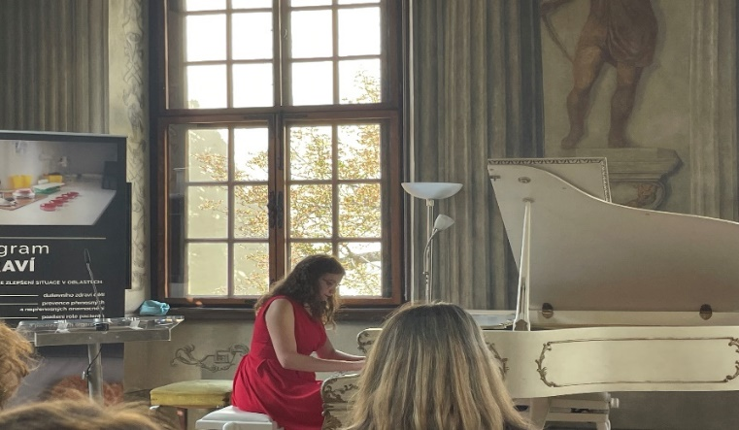
Following lunch, meeting participants were treated to a short piano recital of music by the composer Antonin Dvorak, providing, as stated by the moderator, “food for the soul”.

Tools for building resilience: Digital tools
The afternoon session on tools for building resilience was moderated by Janne Strandrud from the Norwegian Directorate for Health.
Markéta Vaňková, Czech Republic, introduced the Don’t Panic app (Aplikace Nepanikař) that was developed to increase the availability of first-line psychological help for children and young adults in the Czech Republic. One in every three people in the Czech Republic suffers from mental health issues. There is an average of three months waiting period for help, with very few other resources available for those in need of support. To address this, in 2019 two people decided to develop a mobile app to serve as an initial line of support. It currently consists of seven modules on depression, anxiety and panic attacks, self harm, suicidal thoughts, eating disorders, and for personal record keeping (e.g., journaling to record state of mind, or improvement). All modules include practical tips and exercises, based on psychological principles/scientific research. The app also includes a module with help contacts (phone help line and crisis centres) The (anonymous) data gathered from app use reflects that 250 users per day have suicidal thoughts. The app has been downloaded 400,000 times, translated into 11 languages, and is used in 180 countries. The developers are currently working with programmers on a more user-friendly app that they hope to launch by the end of the year.
In addition to the app, a help line was established in 2020, comprised of a chat line (manned by 40 consultants and 5 coordinators) and support by e-mail (staffed by 22 consultants and 1 coordinator, where users can expect a reply within a week). Since the service was established, there have been 5000 chat contacts and 3000 e-mail contacts, of which 34% of users were men and 66% women. The topics addressed included anxiety, suicidal thoughts, self-harm, family and relationships. Key principles of the approach are: anonymity, acceptance, availability, and confidentiality.
Other services that are being developed by “Don’t Panic” include a map and database of all psychologists, psychiatrists, and crisis centres in the country. They also provide online therapies, thereby reducing waiting periods to a matter of days rather than months, as well as reducing the costs of treatment. Currently 12 psychotherapists are engaged and have supported 230 clients through a wide range of therapies. In addition, ‘Don’t Panic’’ began to organise workshops for children in 2021 on how to follow well-being principles and what to do if friends and relatives suffer from mental health problems; so far 800 students and 400 adults have taken part in such workshops.
Don’t Panic is run by a multidisciplinary team of 85 people (psychologists, social workers, students of psychology etc.), who offer their services on a mostly voluntary basis.
Kadri Pahla, Head of Centre, ‘Head Matters’ NGO, Estonia, spoke about ‘’using digital tools in mental health prevention” in Estonia. She explained that the NGO was set up in 2009, when a clinical psychologist and psychiatrist saw that they had too much work, and that they had to do something to promote the mental health of young people and prevent them from needing for their services in the first place. The main tasks of the organisation are to engage in early intervention and to avoid the stigmatisation of mental health problems. The main target group is children and young people between 14-26 years of age.
The first thing they did was to establish a portal, which remains one of the organisation’s most important working tools, as a unique hub of information on mental health. The website recently attracted 1.4 million visitors, which is a lot in a nation of only 1.3 million people (though many visitors also come from Russian-speaking countries, since the information is also provided in Russian). Thanks to funds from the EEA/Norway Grants, the Portal was also able to develop and provide e-counselling services in 2014-2015. As a result, the NGO started to grow and engage in many different activities, like a suicide prevention campaign. A national broadcast company took notice of the campaign, which led to broader news coverage. There have also been campaigns on self-help, mental health ‘vitamins’, and anxiety and anxiety disorders. Ms. Pahla noted that the breadth and width of the audience they are getting is remarkable; at one point the system at a linked health insurance fund went down, since so many people started to order materials when they heard it was available.
Another more recent tool that they have developed is a podcast. 28 episodes have already aired, with approximately 1000 listeners per month, of whom 75% listen to the very end. They have realised that an other place to reach youth is through You Tube videos, that respond to youth searches.
A popular feature of the Portal is the Head Matters Counselling Service, where people can easily seek out help. Youth 16-26 are encouraged to register for 1-3 free counselling sessions, provided in person at a Youth Centre, or on-line (have increased to 398 clients vs. 197 in 2020). Those aged 27 or over can also register to a different service to receive free e-counselling (3439 clients vs. 2430 in 2020). If users have a specific question, they can also pose this to a counsellor by logging in with only an e-mail address (200-250 chat users per month). Users can also receive counselling if they would like to stop or reduce their use of cannabis or similar substances, under the Valik programme (113 clients, vs 102 in 2020).
Ms. Pahla ended by stating that Head Matters faces the continuous challenge of finding a sustainable funding base for all of these services.

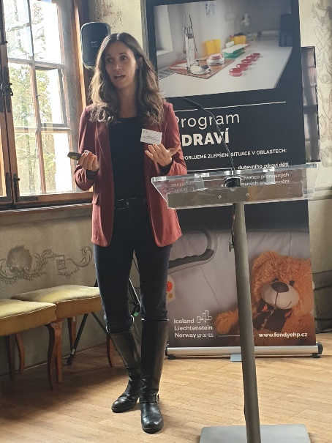
Adélie Dorseuil from the Norwegian Directorate of Health presented on the DigiUng/DigiYouth Portal, that also provides youth centred digital health interventions in Norway. It is a ‘’one stop shop” where youth can go to find answers and support for any health-related concerns, and which is known by over 90% of the youth population. It has over 21.5 million views, which is a huge figure for Norway.
Ms. Dorseuil explained how the resource was established, and what they learned in the process. It began with a drawing in 2014-2015, on how to structure effective health services (in pyramid form, with a strong focus on prevention, actual support services, and then referrals for mor acute services.). In 2018, they issued a broad survey amongst youth in Norway on what they felt the public sector was doing wrong in relation to support for mental health/health and well-being. The responses generated two main lessons: 1) that services should be more youth centred, and 2) that the approach should be more inclusive and positive (”If the services want you to have a problem, you already lose a lot of people”). It was clear that services should be: mobile-based, with extended opening hours, anonymous at first (log-in details, but with the ability to create a rapport), user friendly and well-designed, trustworthy and have easily consumable content (not pages and pages of text). In addition, prior to DigiUng/DigiYouth Portal, the landscape of health services available were fragmented and confusing, with many initiatives overlapping at best or providing contradictory information. A better integrated, multisectoral approach was needed to ensure a “one stop shop”, regardless of which branch of government or organisations owns the content, to provide help when and where children and youth needed it, and whether problems concerned health, school, relationships or family life.
The DigiUng Portal developers began to act on these findings, and the efforts were accelerated through the funding of three projects in 2020. The Portal is currently funded through the activities of a much wider range of projects, and by integrating and leveraging the work of other projects through the ‘’one stop shop” for youth.
The services in the Portal are structured like a pyramid, with at the base the provision of information and guidance. This is provided by a nation-wide interdisciplinary panel of experts, answering anonymous questions, and is the most popular service of the Portal. The Portal includes a large database of content (that is also Google-friendly) designed for youth with articles, videos, and previously answered questions. The developers are continuously updating the information (for instance, on youth rights and sexual abuse issues, improving the Q&A services, and developing an informative map of services to enable youth to find closest youth health clinic). A second range of services focuses on dialogue and self-help (“I need to talk”). The Portal provides access to 30 different chat services to talk with professionals or volunteers about a wide range of topics. There is also a library with access to apps for youth to improve mental health, that are either being tested, or that have been tested through RCTs, and self-help resources related to ADHD and anxiety. The third level of services focuses on individual assistance and follow-up (“I need help”). While DigiUng is currently unable to provide individualized assistance, it can facilitate a process to match a user with appropriate services, like health centres and GPs for 16+ year olds, or youth health centres, school nurses or GPs for youth 13-16. The threshold for youth to seek such help can be very high, so the aim is to build trust, through services provided at the initial two levels. Ms. Dorseuil noted however that there can still be improvements at this third level.
She concluded that “what we learned over the past seven years is that ýouth involvement is short-lived and costly but priceless ... had we done this on our own, we would not be where we are now”. She also stated that “frequent and complimentary approaches to user involvement with repetition create the most solid basis for iterative development.” She also stated that digital ecosystems are the way to go, and that there is no need to reinvent the wheel; existing systems can be built upon and scaled.
Following the presentations, participants inquired whether users abused chat and helplines. The presenters responded that it can happen, but usually it is to test the system, to see, for example, whether a robot is answering, or if they can trust it, which is normal behaviour. It is always evident when a teacher is introducing the webpage, since it leads to funny questions.
When asked about the sustainability of the initiatives, Ms. Vaňková (“Don’t Panic”) indicated that they are currently cooperating with some businesses and insurance companies, and soon want to start dialogue with public authorities and others that can contribute, since they are currently funded through donations. Ms. Dorseuil (DigiUng) raised the importance of creating an ecosystem of different projects and funders to make it sustainable, in case some funding stops or things get outdated, since in the digital world, it is crucial to keep things updated.
Tools for building resilience: NGOs
The final two presentations at the end of the first day focused on initiatives by NGOs to promote dialogue and connection, as key approaches to preventing and treating mental health problems.
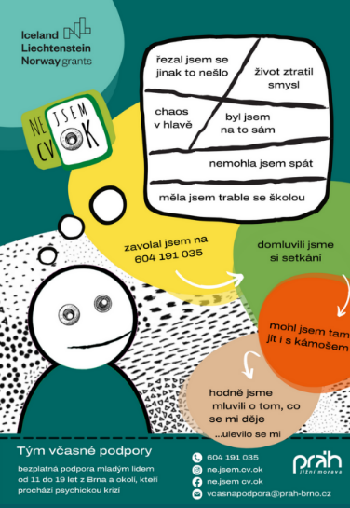
Martin Novák, from the NGO Práh Jižní Morava, Czech Republic, presented on what they are doing to build resilience and strengthen child and youth mental health through early support. Their work involves a complex programme of early detection and early intervention (support) for youth facing serious mental health difficulties and their families and networks. These are youth (11-19 years old), who feel depressed, anxious, lonely and isolated, suicidal, self harming, hallucinating, etc. They may themselves have reached out to the psychiatric care crisis line, or have had a concerned relative, friend, teacher or other practitioner reach out on their behalf. Following first contact, early support teams, consisting of psychiatric nurses, psychologists, social workers or psychiatrists in the area of Brno come together to provide free of charge services and support. They determine how quickly (ideally within 24 hours) to meet, where to meet, what kind of action is needed, and who should be there (e.g., person at the centre of concern, person and/or organisation referring, and/or other supportive people, like family members, friends, teachers, etc.). It is crucial to involve such people, since most of difficulties that youth experience are somehow related to their relationships, and relationships are often a key source of resources. A ‘network meeting’ may also be organised, involving two practitioners, support teams and possibly external practitioners, to get a common understanding of the crisis situation, hear the voices of all participants, and engage in a joint search for resources. While a mental health diagnosis is not crucial to the approach, there is often an underlying traumatic experience that the group ends up talking about.
The aim is also to encourage the person experiencing mental health problems to engage in informal collective activities based on needs and interests, to enable them to connect with others.
The “Open Dialogue” process that lies at the heart of these meetings has been proven highly effective, in terms of e.g., immediate and long term use of medication vis-a-vis ‘treatment as usual’’ and other control studies. There is currently another big RCT trail going on in the UK that has about 400 or 500 patients and first results to be published soon. The process is based on values like listening and compassion, caring relationships and the notion of “nothing about us, without us”.
The NGO also disseminates information on mental health amongst youth through campaigns such as the “I’m not nuts – I’m ok” (ne.JSEM cv.OK) campaign. It also distributes leaflets in schools and medical settings. It aims, in addition, to create a network of professionals in schools and medical settings (private psychiatrists, psychiatric clinics), to build capacity for early detection in schools, and to develop a shared understanding of early support principles that the initiative is based on.
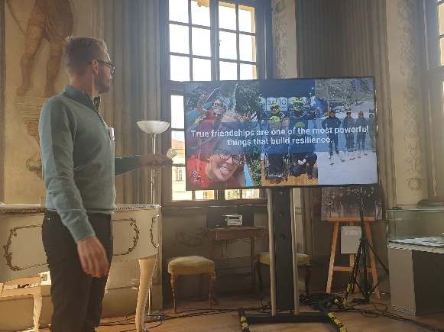
Adrian Wilhelm Kjølø Tollefsen, Director, Youth Mental Health in Norway. The organisation, which receives funding through the EEA and Norway Grants, promotes the power of friendship as the key approach to promote youth well-being. It was started in 2005 by young people, for young people, since many were ending their lives for reasons that boiled down to isolation and loneliness. The solution is to give such youth a reason to choose life, to make sure they don’t feel lonely, have something to look forward to and a feeling of mastery and belonging.
This has been done by establishing local chapters/meeting places of the organisation where youth can come together. The organisation provides support through chats on different topics, like law, nutrition, and sleep, as well as advice and counselling services, and organises activities (including summer camps, hiking, regional meet-ups, YouTube, gaming/Twich, and boxing). It also helps with work training opportunities (for instance, in animal shelters), efforts to re-enter education and a wide range of other things. Mr. Kjølø Tollefsen stressed the importance of pizza to the organisation, since it brings people together; and has therefore saved lives. He told the story of Anne, who made over 200 suicide attempts, but improved as a result of her active involvement in the organisation. When she moved on, she noted that the years in spent in psychiatric treatment cost society more than 3 million euros, but the cost of her recovery was 16 pizzas.
Mr. Kjølø Tollefsen also noted however that while this seems simple, it’s not easy, since building the infrastructure to create robust networks of enthusiastic people requires resources.
DAY TWO
The Next Steps: Children and Youth as Refugees
The second day of the conference focused on ‘’The Next Steps”. The first session on Children and youth as refugees was moderated by Solfrid Johansen from the Norwegian Public Health Institute.
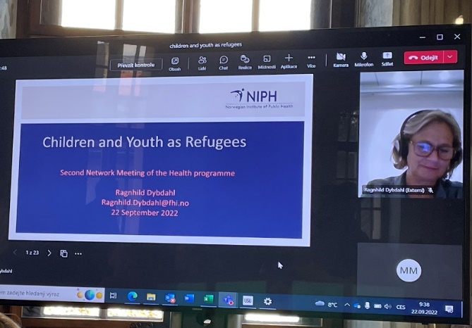
Ragnhild Dybdahl, Norwegian Institute of Public Health. The essence of Ragnhild Dybdahl’s powerful introductory presentation on this theme was that while refugees often face greater mental health problems than the general population, these problems do not necessarily result from the traumatic experience of their flight. Mental health problems amongst refugees are as likely to be linked to the stressors they experience, here and now, such as poverty, discrimination and uncertainty. She showed a picture of Einstein, who was a refugee and reminded participants that refugees have a lot of resources and are more than just a bundle of belongings. Many refugees have experienced danger and fear, and we tend to focus on this, but also loss and grief, which is often lost in the services they are offered. Ms. Dybdahl stressed that most refugees have very normal reactions to stress, separation, and loss that need not become pathological; they are both resilient, and vulnerable, like all human beings. While the prevalence mental disorders is, at 22%, higher for refugees than for the general population, it also means that most refugees do not develop a pathology. While we can’t do much about refugees’ previous trauma, we can something about the current conditions and daily stressors that refugees face, which are most likely to be affecting their health.
Ms. Dybdahl also stressed that refugee children and youth are, above all, children, with the same needs as all children. As refugee children themselves indicate, they just want to be treated like others. This means that like all children, they need health, education, protection, nutrition, love, and nurturing care, as powerful protective factors that moderate risk factors. Ms. Dybdahl also stressed that having a care-giver (a parent or other) is perhaps the most important protective factor for children, and that being part of a community, and feeling connectedness, is crucial to mental health. We therefore need to consider socio-emotional well-being as a crucial part of children’s basic needs.
Following the presentation, participants asked what Ms. Dybdahl thought about unaccompanied minors placed in host-family homes. She responded that if they are young, host-family homes are a good strategy, otherwise, it is more common for older unaccompanied minors to live together in homes, but it is not clear what is preferable. If language is an issue, an attempt should be made to place a child with families that speak their language. In Norway, most refugee children are 16 or older and many speak English (this could be explained, in part, by those who are able to flee having more resources). In general, all refugees should have the opportunity to speak their native language, since this is very important to mental health.
Markéta Ferencová Hrodková, Ministry of Labour and Social Affairs, Czech Republic, presented on the situation of children and refugees in the Czech Republic, particularly before 2021.
According to 2021 data from UAM, there were approximately 237 unaccompanied minors in the Czech Republic. Most come from Afghanistan (199), Syria (14) Morocco (8), Turkey (4) and other countries. Most are boys aged 15-17, with some as young as 11-14. These children have the same social and legal protection as all children in the Czech Republic, and they receive support based on an assessment of their individual needs. Most of the unaccompanied minors don’t want to stay, and see the Czech Republic as a “transit country”, as they try to reach relatives in other parts of Europe.
There are also currently 390,000 refugees in Czech Republic, of which 36% of children, most of whom are coming with their parents (primarily mothers). Regional assistance centres registered more than 30,000 “separated children”, who came without their legal representatives, but instead with other close family members, friends or others. According to 2022 data, there are also about 200-300 unaccompanied minors from Ukraine in the Czech Republic. Most of these are boys who are 16 or older, but one-third are girls, while seven were under the age of nine. All of these children are provided with health insurance and can use networks or registered social services. Efforts to provide them with social, legal and educational advice, as well as to provide them with professional psychosocial services are still underway. Ms. Ferencová Hrodková noted that with children it is much more difficult. They also need long-term accommodation, and flexible and secure sources of information (telephone lines, online platforms for young children, etc.).
In response to questions from the audience, Ms. Ferencová Hrodková indicated that there is very good cooperation between NGOs and the government when it comes to responding to the needs of child and youth refugees, and that they are cooperating with UNICEF to standardise approaches to training. In addition, they are using volunteers to help with translation and to help accommodate children. The state pays for accommodation centres, or for specialized accommodation in Prague, depending on the age of refugees. The first choice is to place refugee children with relatives, family friends or others who have a close relationship with a young refugee.
Marcelina Mroczkowska, Ministry of Health, Poland presented on the situation of refugees from the Ukraine in her country. They received many Ukrainian refugees, around 6.5 million, although some have already returned to Ukraine or moved on to other countries, so currently there are 4.5 million, of whom 1.3 million (44%) are under the age of 18. Polish people were very stressed and eager to help, offering spare rooms in their houses, but most Ukrainians preferred to stay in special accommodations.
All Ukrainians that crossed the border after war started (Feb. 24) have the same rights as Polish citizens; they can apply for a so-called PEseL-identification number that enables them to get access to public services like medical care, social benefits, or to set up a business. Reception centres have been set up where the refugees can receive information, hot meals and medical care. The main challenges lie in providing psychological support to the youngest refugees. The government has therefore created help lines and on-duty specialist services to provide support in Ukrainian and Russian, so they can indicate what problems they are facing and seek help. An ombudsman has also been appointed to help. There are also online chat tools in Ukrainian. The Ministry of Health is currently processing a draft regulation to pilot therapeutic interventions for people who have experienced conflict, and their families. They are disseminating leaflets, offering subtitles on the news in Ukrainian, and there are websites with separate pages or sections in Ukrainian. NGOs have helped a lot. Many Ukrainians want to return home, but many might stay, given the uncertainty of the situation.
Questions and comments focused on how it was impressive it was to see how these countries had come to the support of these refugees. At first it was primarily individuals and civil society organisations that provided help. It took a while for the government to begin to donate money, food and clothes. A lot of action was also taken by local governments, who are not always the richest, but sprang to help. It was noted that it is important to be vigilant of the ‘’dark side’’ of helping, since it could also lead to child trafficking, etc.

The Next Steps: EU policy in the field of children’ and adolescents’ mental health, lessons learnt and the next steps for the network
This morning session was moderated by Pernille Venner Dehli, Norwegian Directorate of Health.
Ingrid Stegeman, Programme Manager, EuroHealthNet (a non-profit network based in Brussels) presented on Key Strategies and initiatives at European level to improve child and adolescent health. These strategies and initiatives can help to support and leverage the kinds of projects and programmes being financed through the EEA and Norway Grants, to help embed, mainstream and scale them in the future. She introduced EuroHealthNet, a network that focuses on health promotion and prevention by addressing the underlying determinants of physical and mental health. She noted that, as a result of the COVID-19 pandemic, health at EU level (including mental health) is receiving much more attention. As an illustration, the budget of the current EU4Health Programme (2021-2027) is now ten times greater than for previous health programmes. It remains a challenge, however, to ensure that most of this money isn’t spent primarily on ‘bio-medical’ approaches, but that substantial funds also go to measures in the area of health promotion and prevention, such as the measures discussed throughout this meeting. There have been calls by some EU Member States and the EU Parliament for an EU Mental Health Strategy. A recent positive development is that Commission President Ursula von der Leyen, in her September 2022 EU State of the Union speech, announced a “new comprehensive approach” on mental health. Ms. Stegeman encouraged meeting participants to get involved in the process of developing the Strategy, to ensure that it supports and is aligned with developments in their countries raised during the meeting. Ms. Stegeman also raised the EU Healthier Together Initiative and other initiatives funded through the EU4Health Programme, that focus on the transfer and implementation of good practice in the area of health determinants, including mental health.
There are many other funding programmes and initiatives across the EU that can help support the kinds of initiatives raised at the meeting, like the EU Child Guarantee, designed to ensure that all children in the EU have access to their basic needs. All countries have a EU Child Guarantee Coordinator and have/are developing National Action Plans in this area, and it would be good for programme managers to link up to these. For instance, they should ensure National Action Plans also cover mental health and the kinds of measures discussed at the meeting as crucial protective factors. Ms. Stegeman also raised the ‘Better Internet for Kids’ Strategy, and the EU Technical Support Instrument as additional relevant policies/tools to take forward the objective of improving the mental health of children and youth. She concluded by making reference to WHO Europe’s Mental Health Coalition, and the new WHO Europe and Greek Government initiative to promote the quality of mental health care of children and adolescents, as important initiatives that the Network should link up to.
Following Ms. Stegeman’s presentation, network members split into two working groups, to discuss the questions of whether they felt their project/programme was helping to put child and adolescent health issues more strongly on the policy agenda of their countries, and if they were contributing to more systemic change in their countries.
Participants noted that sometimes, as in Estonia, the circumstances are right for ‘stars to align’, and society is ready for a more holistic and human approach. This, however, depends very much on the context within countries. It can be very difficult, for example, to provide support to the four million children with multiple risk factors in Romania, like those whose parents are working abroad. Some specific programme outputs, like the survey on child mental health in Romania, can help spur more systemic change, as they provide a more comprehensive overview of the situation.
The results of that survey served as the basis for the Strategy for Child Mental Health. Similarly, the manual setting out standards for community services and the significant investments in human resources are also very important to help mainstream initiatives and promote their sustainability.
Nevertheless it was noted that there is still a lot of work to be done around changing mindsets and around the whole concept of mental health. It can be hard for people to accept and understand that, for example, common parenting styles and/or very heavy educational curricula can, in and of themselves, be a risk to children’s well-being. Teachers in particular are often too overwhelmed to try new things. If all relevant groups are targeted in a more consistent and systemic fashion, through both bottom-up and top-down approaches, it can lead to change.
Participants agreed that well-developed public strategies matter. They should be aligned at all levels of governance and be evidence-based or informed (something whichprojects and programmes can contribute to in an important way). Before any new projects and programmes are accepted by public authorities in Lithuania, for example, they must first consider how they fit into a broader strategy, and with whom they will collaborate. It is also important to consider which party could be strongest in providing the services sustainably once a project ends. It is also important to have alternatives to funding, and to think about institutional structures. Participants noted that “it’s like a LEGO process” to make services available to all.
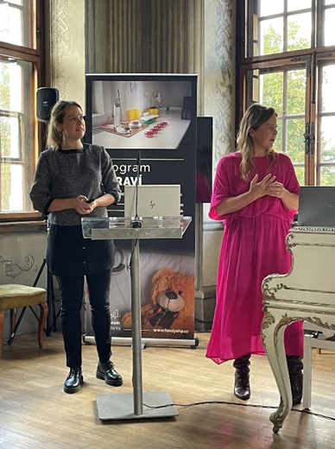
The final session of the meeting on Health in the next period of the EEA and Norway Grants and the next steps for the network was led by Gudrun D. Gudmundsdottir from the EEA and Norway Grants and Pernille Dehli, from the Department of Global Health, Norwegian Directorate of Health.
Ms. Gudmundsdottir indicated that although negotiations are still at a very early stage, it looks like health will still be on the agenda of the next funding programme. The aim is always to have fewer, more interlinked, and comprehensive programmes. She also indicated that it would be good for the network to collaborate further before the end of this programming period, and to find ways to create more synergy between this network and the one on violence and domestic violence. There is no corresponding network in this field of child and youth mental health at EU level, so it brings added value. She also noted that the meeting provided a lot of learning on challenges and lessons learned. While the intention was to have a meeting every year, COVID-19 interfered with these plans, so it could be good to have one meeting every other year. Network members will consider this.
Ms. Dehli reminded participants that, unless they have told organisers otherwise, the core PO represents their country in the network, and they are responsible for the distribution of all relevant materials in their countries. Lithuania indicated plans to have a next PO meeting, linked to a Conference on Mental health in June/July 2023. They indicated that this could also be a nice opportunity for the network to meet, thereby combining these events for an even more comprehensive programme. This would also give the POs more time to exchange on technical issues, related more to the management of the funds and projects
ANNEX I

Terms of referance for EEA AND NORWAY GRANTS'
Network – children and adolescent health

Approved
9. SEPTEMber 2022

Background

The Norwegian Directorate of Health and the Norwegian Institute of Public Health have the role as Donor Programme Partner in Poland, Romania, Estonia, the Czech Republic and Lithuania.

The network is an attempt to establish a multilateral capacity building arena as an addendum and possibly a replacement for some of the bilateral activities in the health programs and health related projects under the EEA and Norway grants.

Experiences from the last programme period (2009-2014) show that Norwegian organizations with specific expertise are contacted for exchange of competence from organizations in multiple recipient countries.

The Financial Mechanism Office prepared an overview over all relevant projects in the 2014-2021 mechanism. This overview showed an overlap of topics, particularly on children's and adolescents' health.

For that reason, it could be useful to build a network in order to contribute to sharing across countries, as well as to strengthen bilateral relations with the donor countries.

Objectives

We will aim to:

- Keep health on the agenda for the next funding period of the EEA and Norway grants by demonstrating the significant impact of public health on the society and on sustainable growth.

- Enable the exchange of experiences, challenges and lessons learnt between all relevant programme areas working with the topic of choice and between countries.

- Build capacity in selected thematic areas, as well as capacity in project management, implementation, dissemination etc.

- Facilitate and strengthen new cross-country partnerships

- Contribute to sustainable and effective programme implementation

format and output

- The network meetings should be interactive and build on active participation – participants are encouraged to contribute – by giving prepared presentation and in the discussions.

- The countries (Program Operators) appoint relevant participants to the meetings.

- The Donor Program Partners appoint or invite relevant experts to the meetings

- Ideally, network meetings should be organized biannually rotating between the countries, supplemented by webinars in specific cases

- The topics of the network meetings should be relevant for the day-to-day work within the projects and contain of exchange of knowledge and experience; both in thematic areas (like mental health among adolescents, treatment and preventive measures) and technical issues (like implementation, dissemination and project management).

- The organizing country will decide on the topic of the meeting

- The participating countries are free to open up the meeting to external participants interested in the selected topic of the meeting, but some time should be allocated to the network only

- The DPPs will support the organizing country in the planning of the meeting

- A short report should be prepared from each network meeting.

Main Activities

The network will meet on a regular basis. The organizing country and the DPP will agree on the topic for the meeting.

Preliminary plan for network meetings 2019 – 2024 (in alphabetical order):

Responsible for network meeting | 2019 | 2022 | 2023 | 2024
The Czech Republic |  | X
Estonia
Lithuania |  |  | X (tbc)
Malta
Norway | X
Poland
Romania |  |  |  | X

organization and roLES

- The network should be accessible for programme operators (PO), project promoters (PP), national focal points (NFP), other beneficiary countries' representatives, donor programme partners (DPP), donor project partners (dpp), other countries' representatives and representatives from the financial mechanism office (FMO). The organizing country is free to open up the meeting for all other interested parties.

- The POs and PPs and their partners in donor countries should contribute with experiences from previous and present programme implementation.

- The Norwegian Directorate of Health and the Norwegian Institute of Public Health will take part in the planning of the network meetings and support the organizing country in identifying relevant experts.

6. Communication

- All information related to the network will be published on the following web-pages:

https://www.helsedirektoratet.no/tema/sosial-ulikhet-i-helse/eos-midlene-stotter-helseprosjekter-i-europa and/or http://fhi.no/kk/internasjonalt/eos/nettverk

- The countries are encouraged to publish the network activities on their programme web pages

