[Place, date]
Name
Address
Postal code

Result of X-ray examination for tuberculosis (TB)
You have been examined for tuberculosis (TB). The X-ray examination showed no signs of TB disease.
It is possible to develop TB later so you should know the most common symptoms.
Someone who has a cough for 2–3 weeks or more could have TB in the lungs. The most common signs of lung TB are:
- Coughing up phlegm from deep inside the lungs, sometimes with blood
- Pain in the chest

Other common signs of TB (both lung TB and TB in other parts of the body) are:
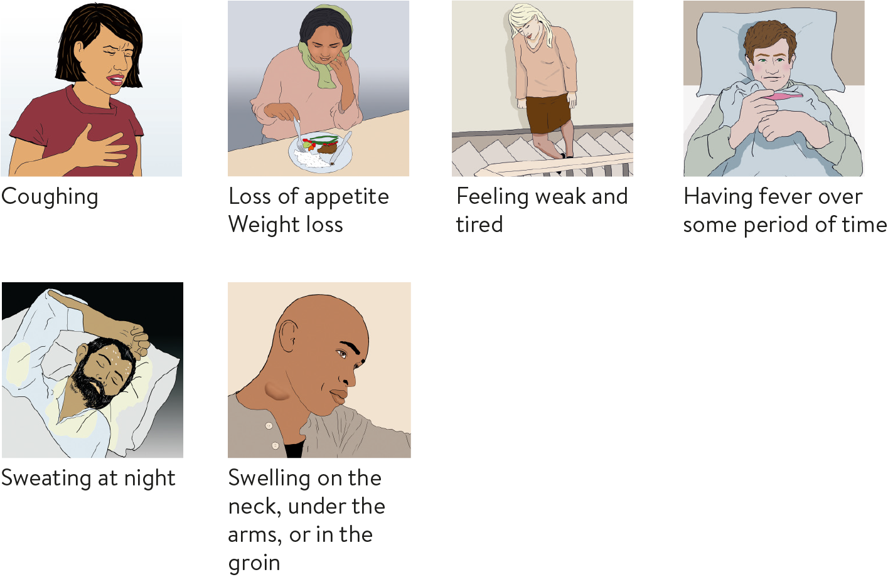

These are also common symptoms of other diseases. If you suspect you may have TB, contact your doctor. The municipality where you live can give you information about how to get medical help.

All examination and treatment of TB is free in Norway.

Sincerely,

[Name, title]
[Municipality]
[Municipality’s telephone number]
[Infection control office]

